**ML System Design - Ad Click Predictions on Social Platforms**

Video: https://www.youtube.com/watch?v=wxUx3gIUEsk

Business Objective:



Ads on Different Platforms



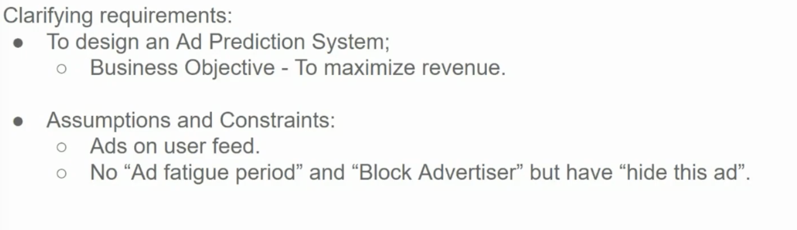

* Is there an existing system already in place?
* What is the main objective: accuracy, latency?
* Is there labeled data? If so, how much
* Can we trust the quality of data coming in?
* Where the model will be deployed? [cloud, edge, etc]
* Are there any constraints or limitations on model complexity or size?
* What are the key success metrics for this ML system in the long term?

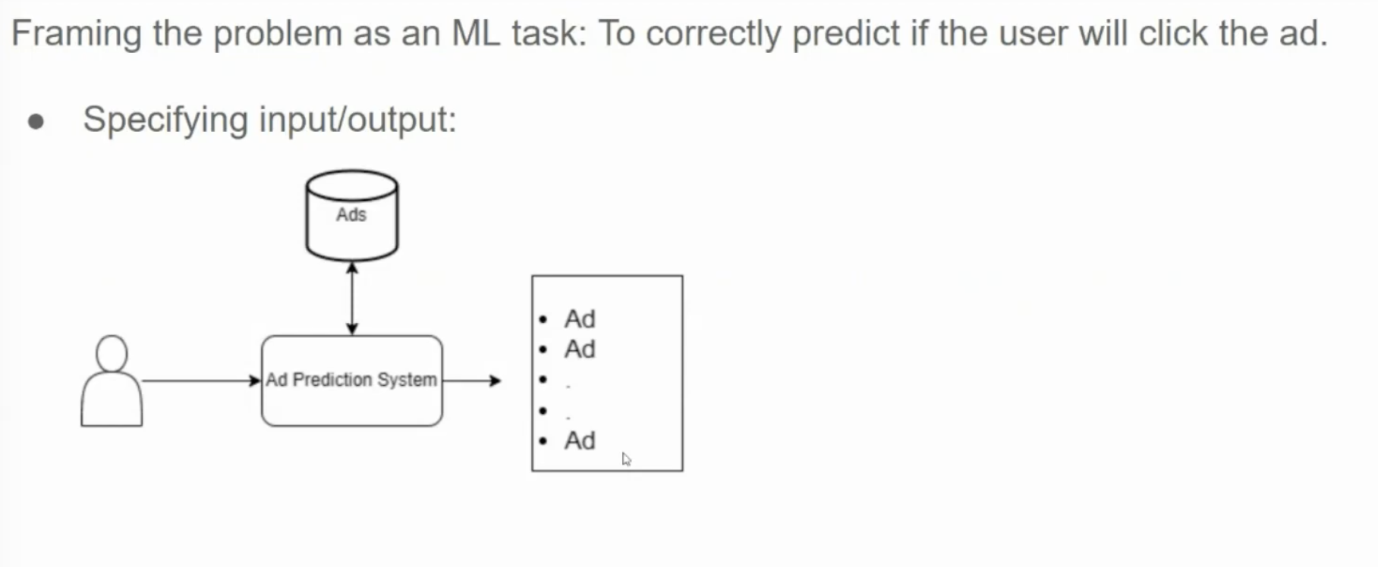

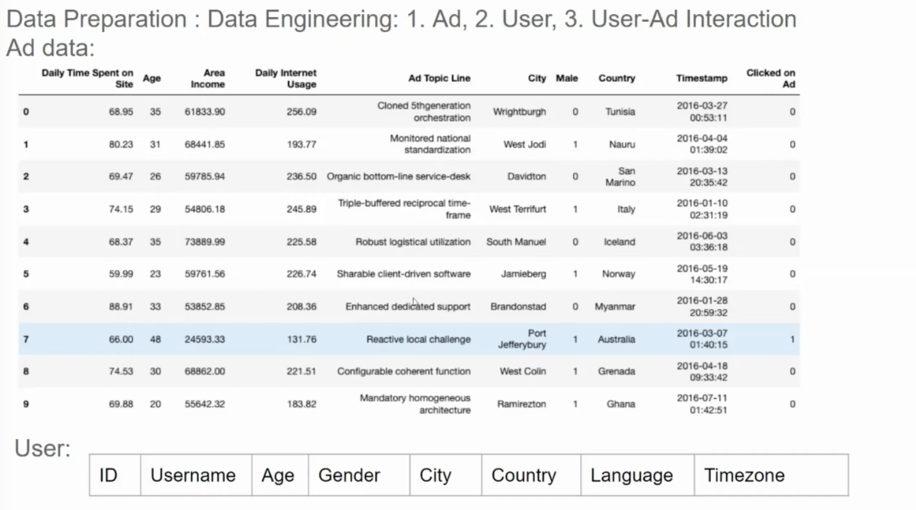

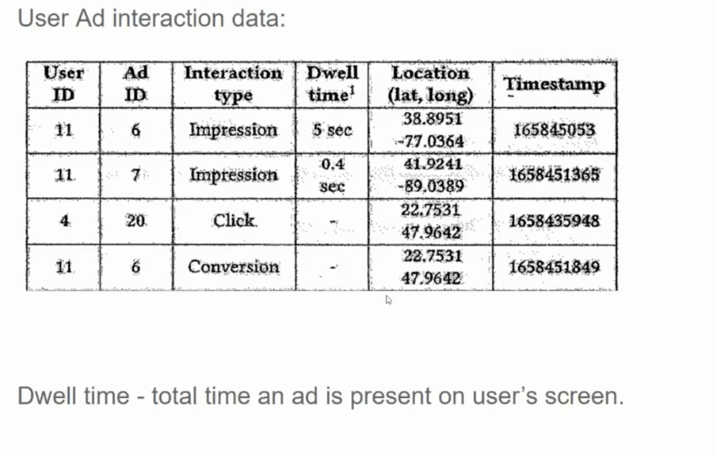

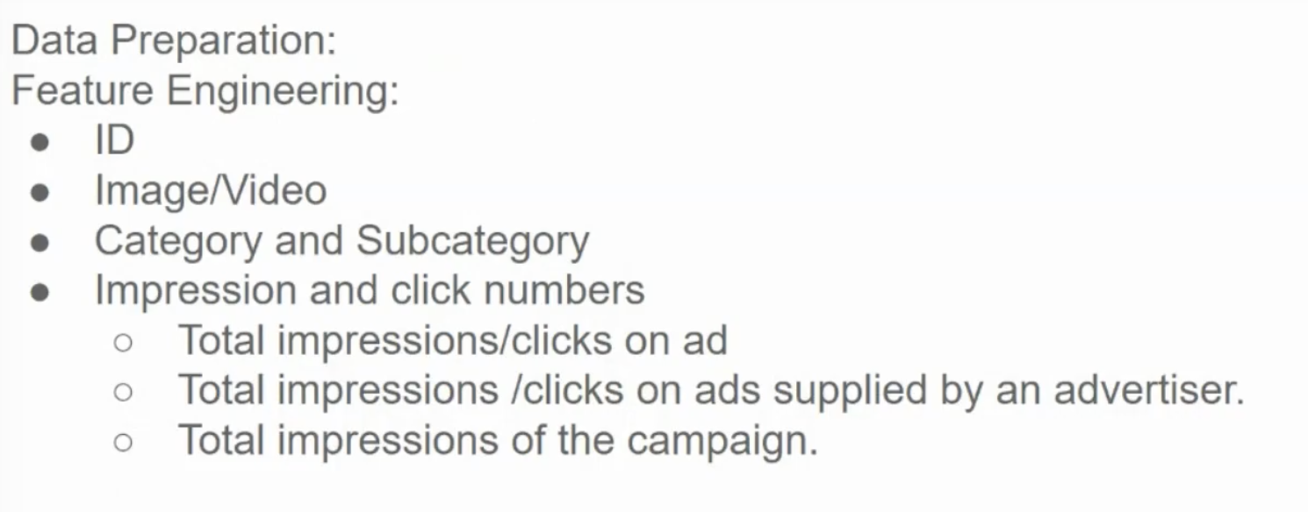

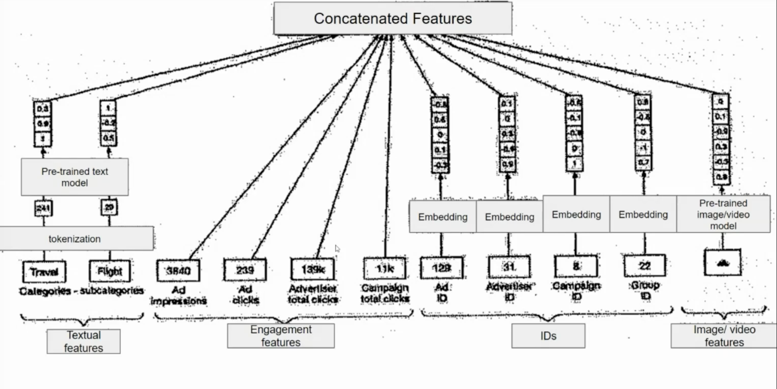

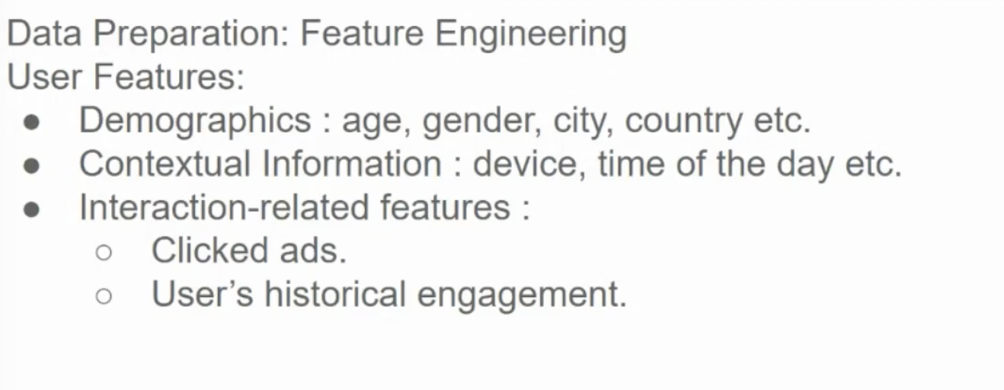

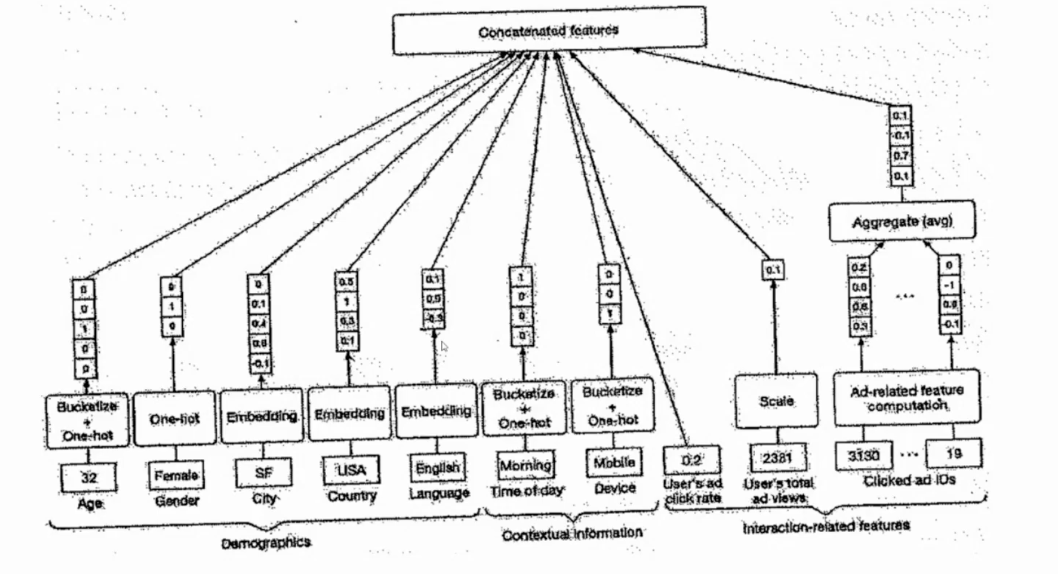

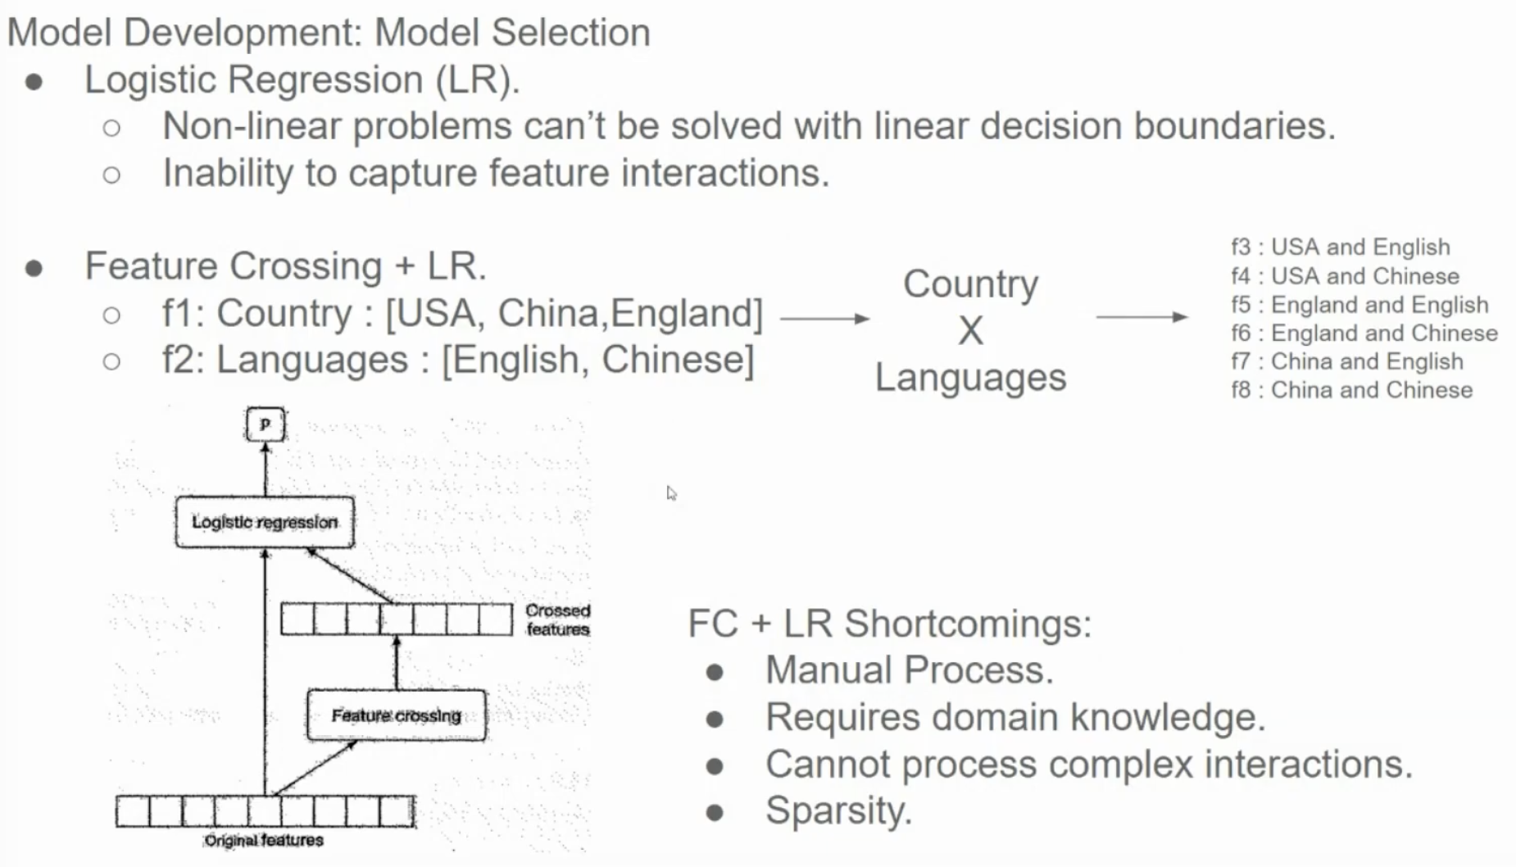

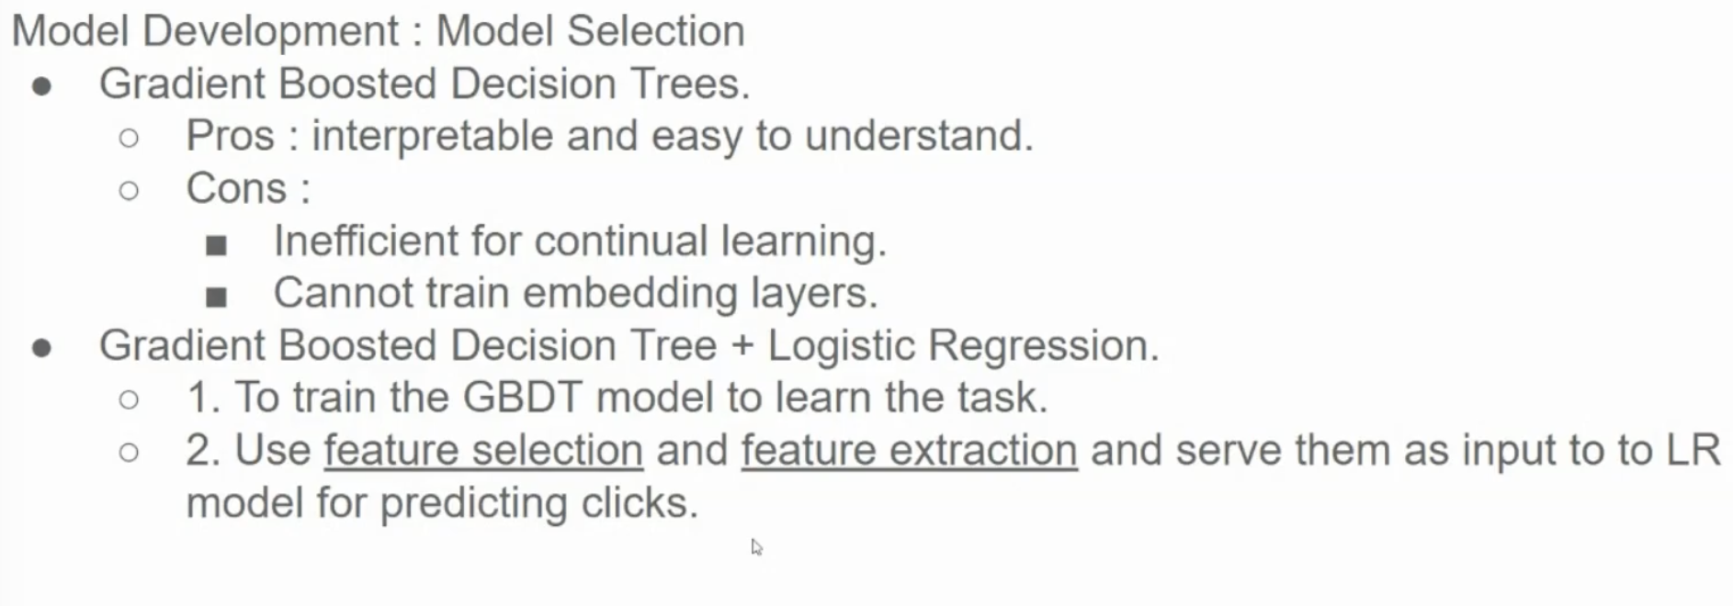

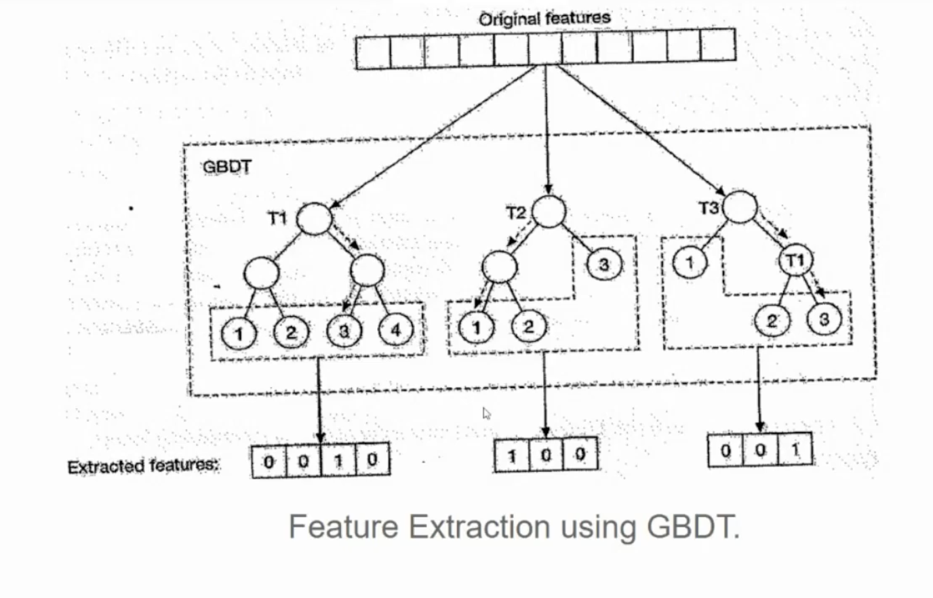

**Feeding GBDT Features into a Logistic Regression Model:**

1. **Extract Features:** For each data point, traverse each tree in the GBDT ensemble. At each node, record the decision made (e.g., left or right).
2. **Create Feature Vector:** Concatenate the decisions made at each node for all trees to form a feature vector for the data point.
3. **Feed to Logistic Regression:** Use these new feature vectors as input to a logistic regression model. The logistic regression model can then learn to classify data points based on these GBDT-derived features.

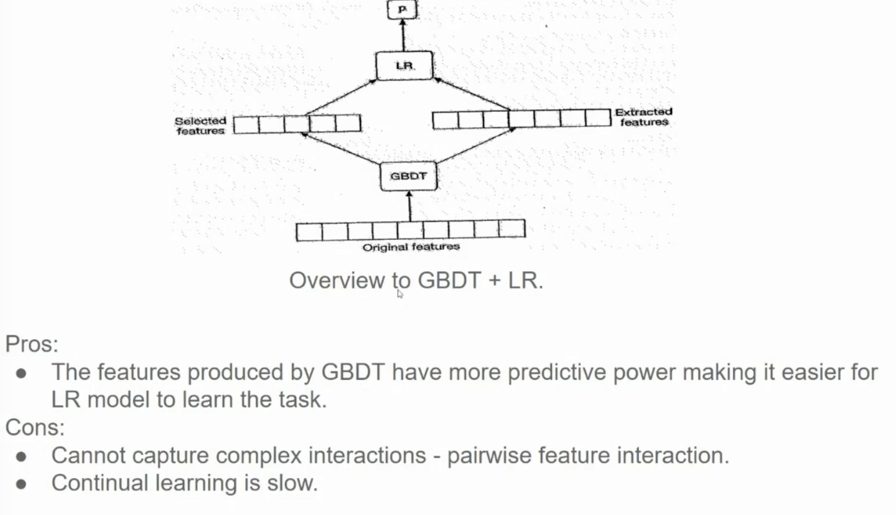

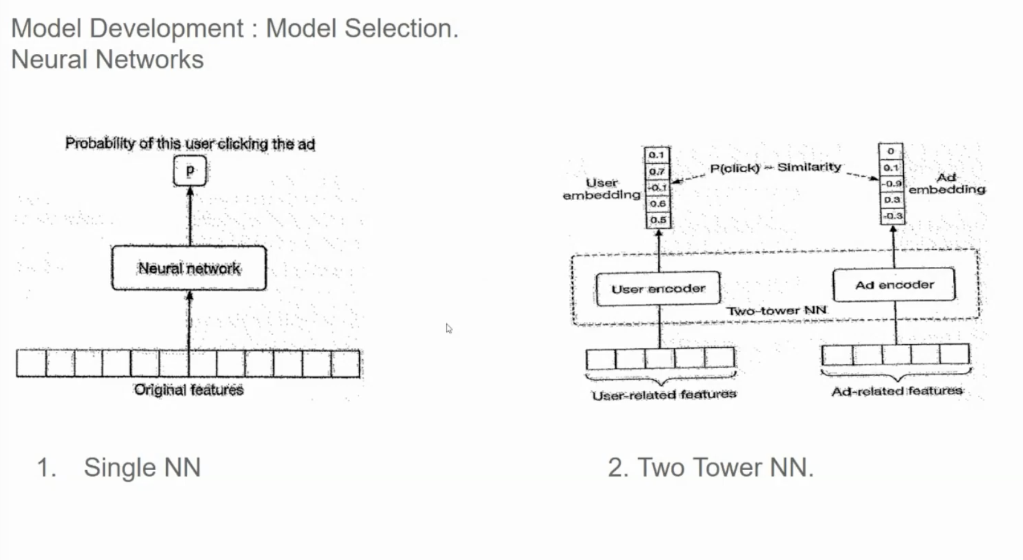

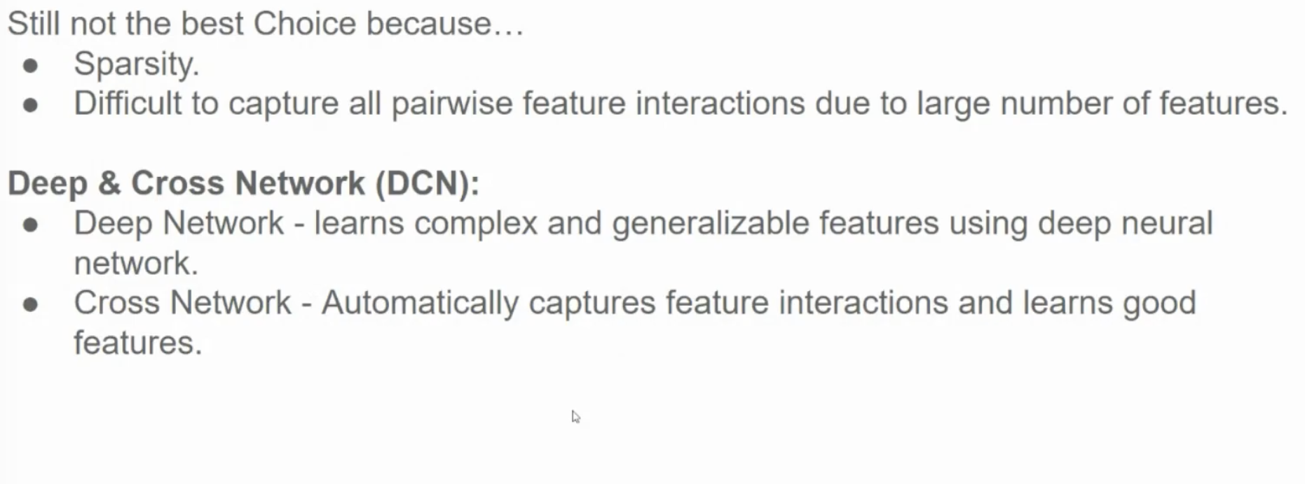

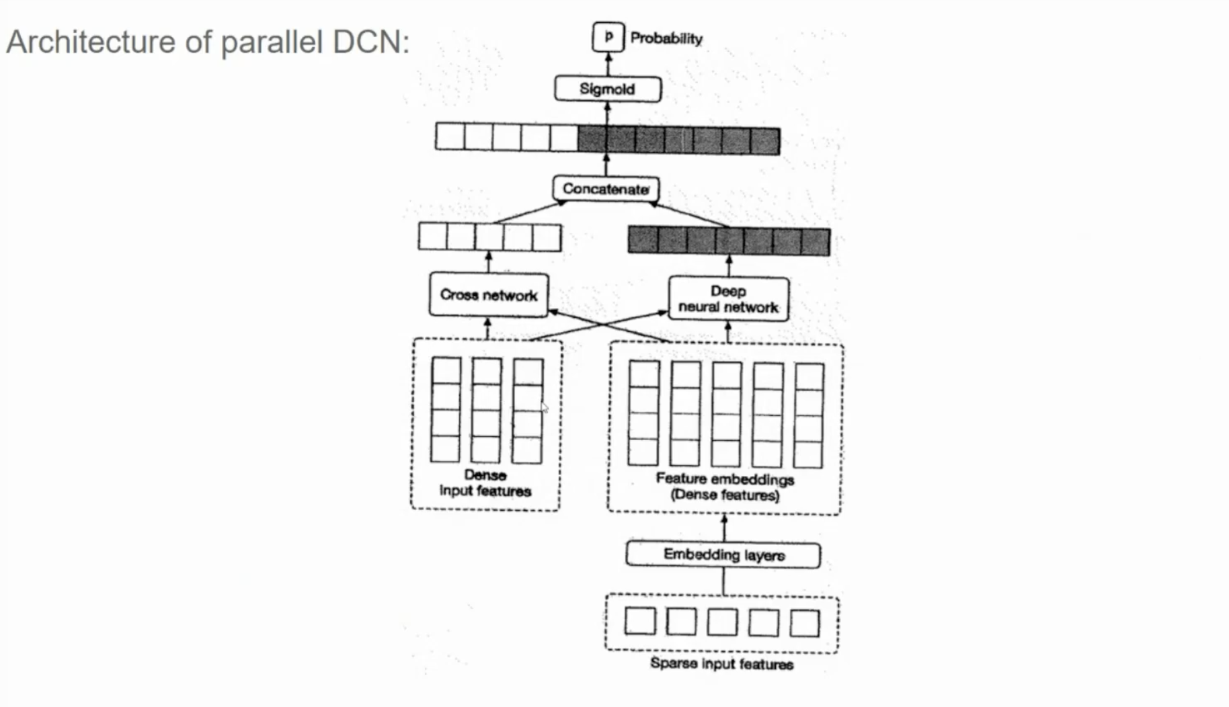

illustrates the architecture of a **Parallel Deep Crossing Network (Parallel DCN)**, which is a deep learning model commonly used for click-through rate (CTR) prediction in online advertising.

**Here's a breakdown of the architecture:**

**Input:**

* **Sparse Features:** Categorical features like user ID, product category, etc., which are typically represented as high-dimensional sparse vectors.
* **Dense Features:** Numerical features like age, income, etc., which are usually represented as dense vectors.

**Feature Processing:**

* **Sparse Features:** Sparse features are fed into embedding layers, which map them to dense vectors of a fixed size. This allows the model to capture the semantic meaning of the categorical features.
* **Dense Features:** Dense features are directly fed into the subsequent layers.

**Model Structure:**

* **Deep Neural Network (DNN):** Both the embedded sparse features and dense features are fed into a deep neural network (DNN) to learn complex non-linear relationships between features and the target variable (click probability).
* **Cross Network:** The cross network is a novel component that introduces interactions between different features. It works by iteratively combining features from different layers, allowing the model to capture higher-order interactions.

**Output:**

* The output of the DNN and cross network is concatenated and fed into a sigmoid activation function to produce the predicted click probability.

**Key Points:**

* The parallel structure allows the DNN and cross network to learn different aspects of the data and complement each other.
* The cross network is particularly effective at capturing feature interactions, which are crucial for accurate CTR prediction.
* The model can be trained using techniques like stochastic gradient descent and backpropagation.

